**HOMEWORK 7**

**Jeremy Scheuerman**

**NAND**

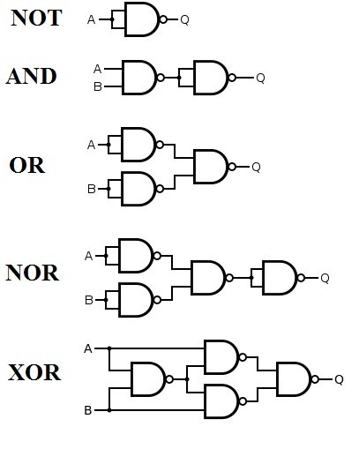

**NOR**

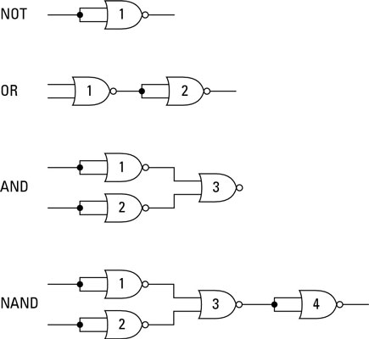

A very useful graphic I used to assist on this homework

1. Realize Z = A’B’C’ + A’C’ + ABC + AC using only NAND gates. Use as few gates as possible

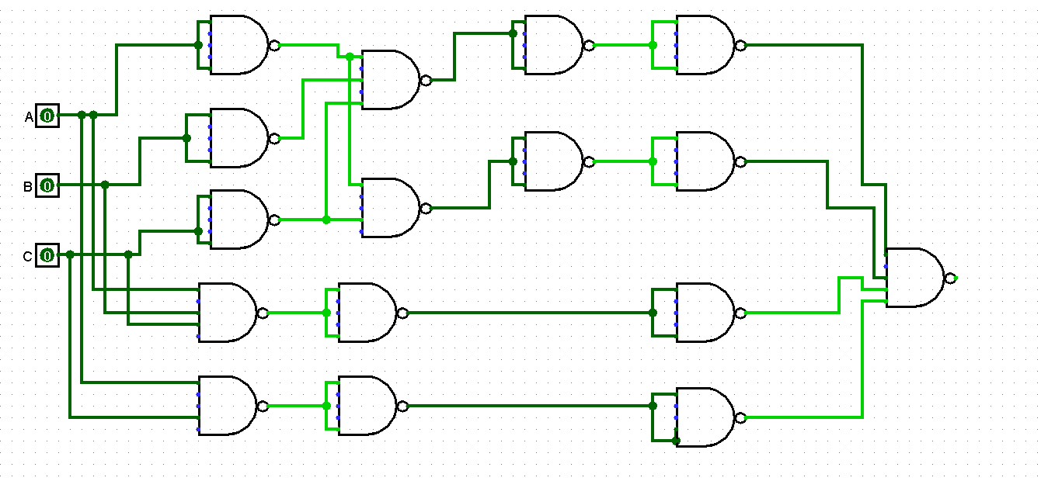

1. Realize Z = (A+B’+C) (A’+D) (A+B’+C’+D’)(A+C’) using only NOR gates. Use as few gates as possible

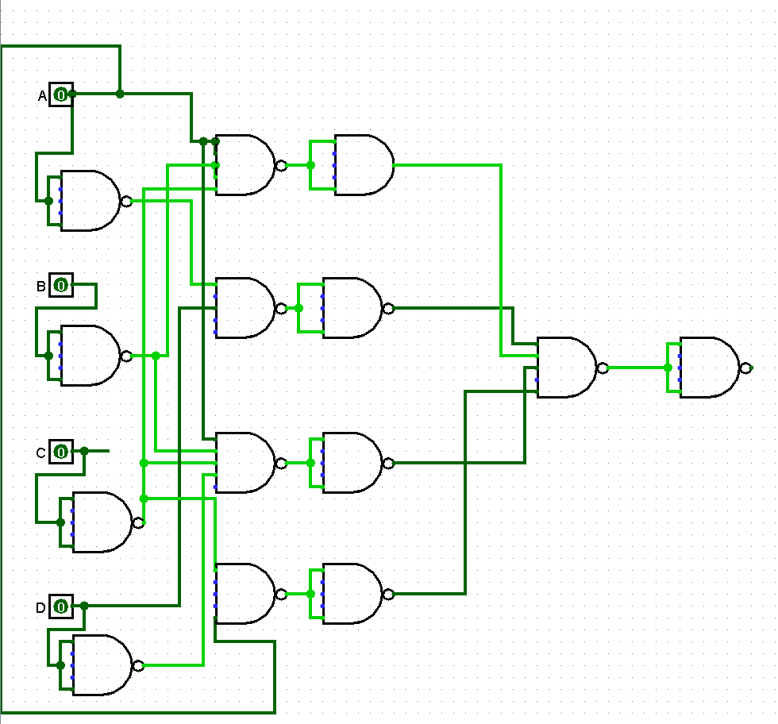

1. Convert the following circuit to all NAND gates

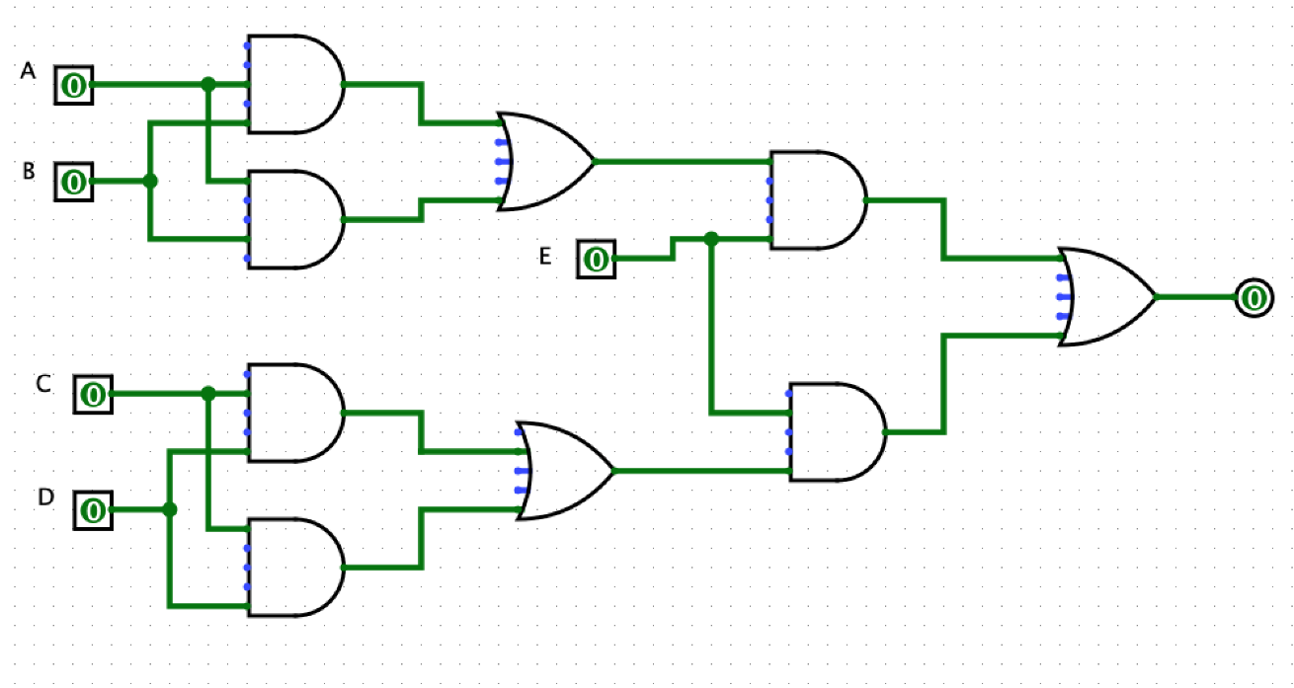

Converted to Nand

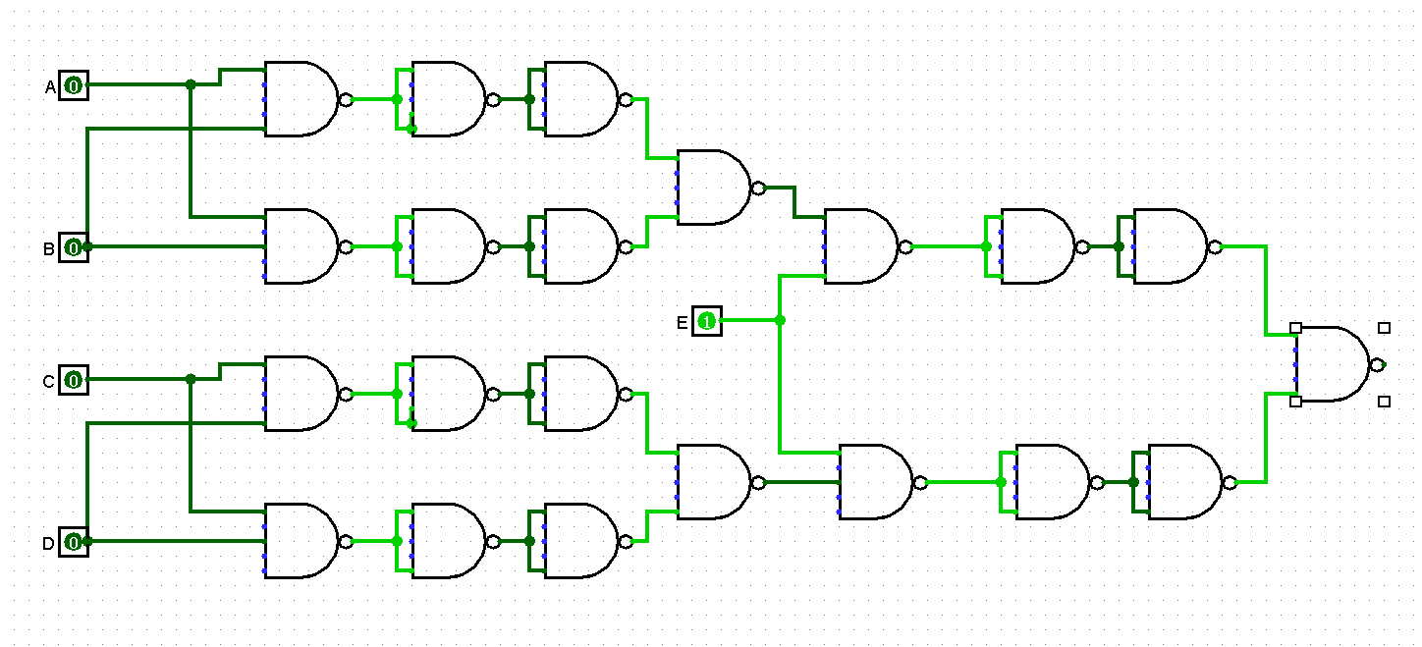

1. Simplify the following Boolean function using Boolean Algebra or KMap. Draw the Logic diagram using basic gates, then draw the equivalent NAND only configuration.

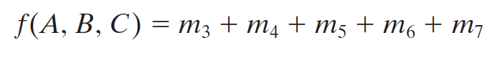

Basic

1. Convert the following circuit to all NOR gates

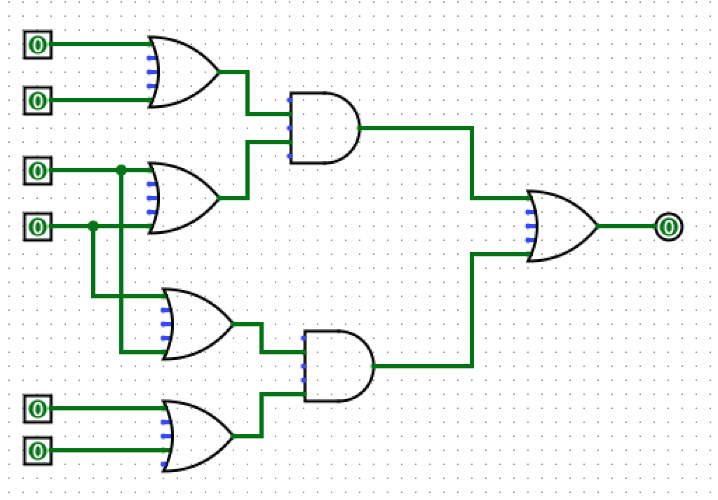

Converted to all nor gates

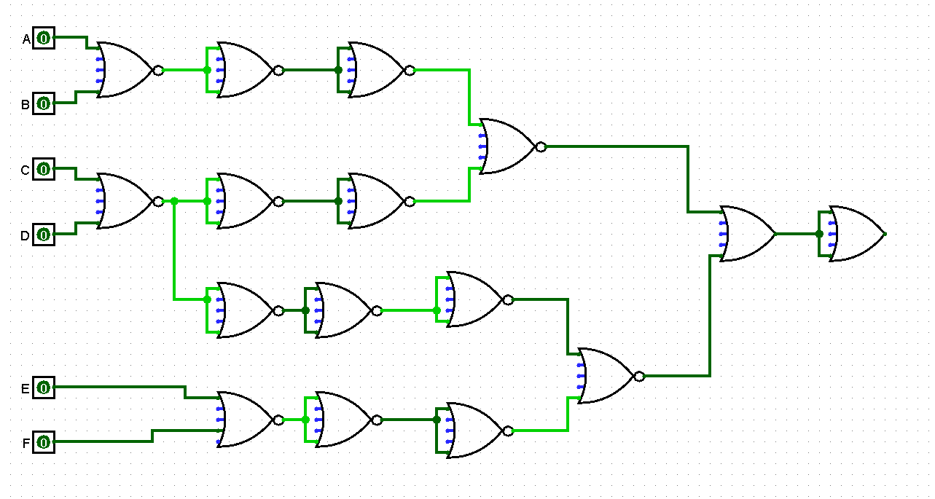

1. Simplify the following Boolean function using Boolean Algebra or KMap. Draw the Logic diagram using basic gates, then draw the equivalent NOR only configuration.



A+BC

Basic gates

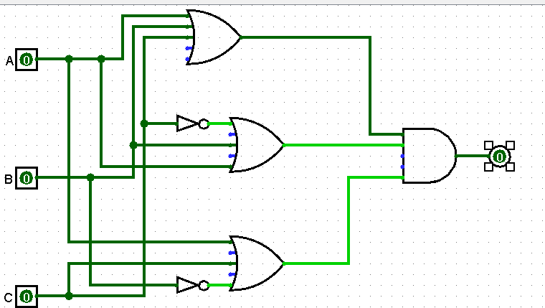

Nor only

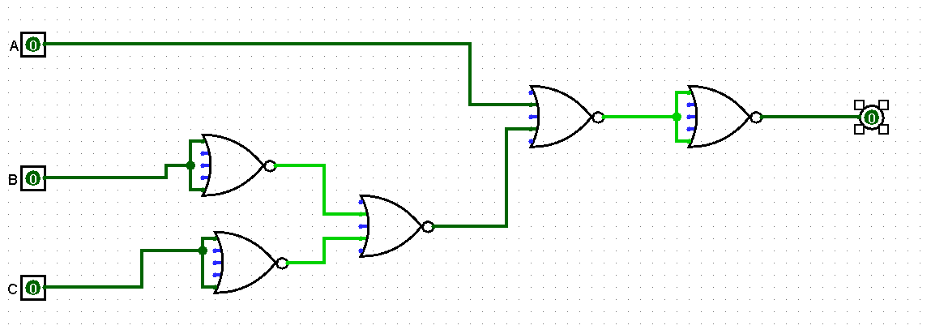

1. Based on the following truth table:

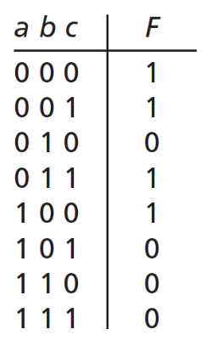

* Write a Boolean expression for F as a function of A, B and C

A’B’C’+A’B’C+A’BC+AB’C’

Simplified

A’+B’+C’

* Design a circuit that implements the truth table using basic gates

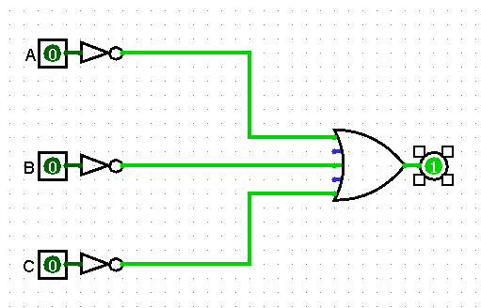

* Using only NANDs, design a circuit that implements the truth table

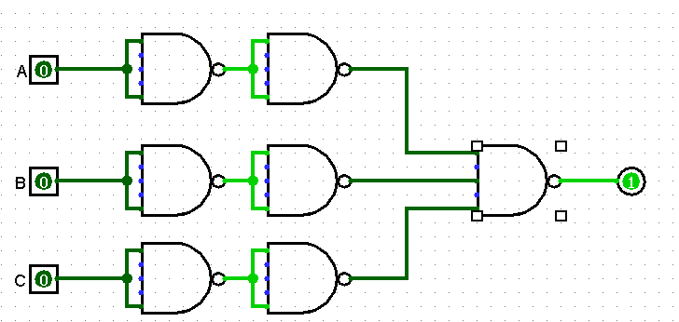

* Using only NORs, design a circuit that implements the truth table

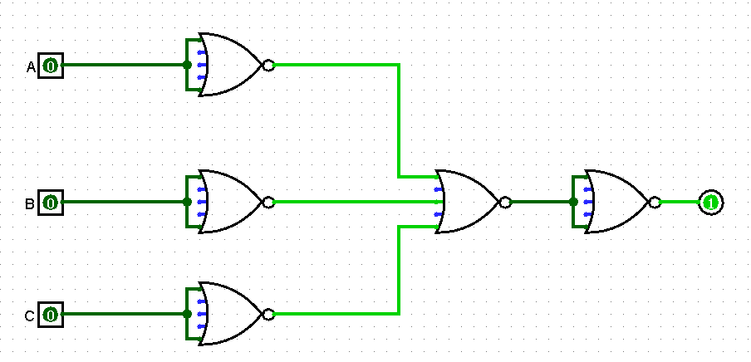

1. Build a Logic Diagram which represent a 4 input ODD function. Show all your work (Boolean Function, Truth Table…)

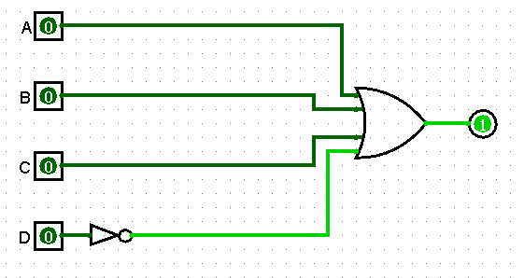

1. Build a Logic Diagram which represent a 5 input EVEN function. Show all your work (Boolean Function, Truth Table…)